**Threads states :**

* Newborn
* Runnable
* Running
* Non-Runnable (Blocked)
* Dead (Terminated)

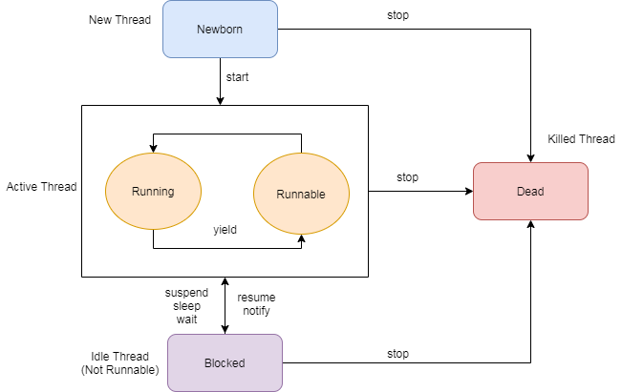

**Newborn:**

When thread is created using new operator, thread state is new state. At this point thread is not alive.

**Runnable**:

When we call start() method on the thread object, it’s state changes to Runnable. The control is handed over the Thread scheduler to finish its execution.

**Running**:

When a thread is executing, its state changes from Runnable to Running. Thread scheduler picks one thread from Runnable thread pool and changes its states to Running. Then CPU starts executing this thread.

**Blocked**:

A thread can be waiting for other threads to finish thread join or it can be waiting for some resources to be available. Once the wait is over its state changes to Running and moved back to runnable thread pool.

**Dead**:

Once thread is finished executing, its state is changes to Dead.